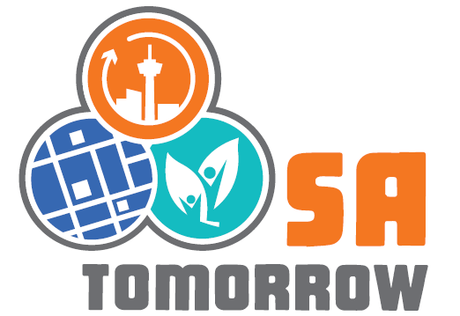

Contact – Melissa S. Sparks, 210-207-1011, melissa.sparks@sanantonio.gov

April 11 Kick-Off Event Introduces SA Tomorrow to the Public

SAN ANTONIO (April 11, 2015) – The City of San Antonio, with partnering agencies, is hosting a kick-off event today for SA Tomorrow, the planning effort that will engage the community in preparing for the additional 1.1 million more people expected to live in the San Antonio area by the year 2040.

The free event, being held at the SAISD Alamo Convocation Center on Tuleta Drive, includes family-friendly activities that engage all age groups. The purpose is to reiterate the “preparing for growth” theme, initiate conversations about the SA Tomorrow planning effort, and provide basic information about each of the three plans that form the SA Tomorrow initiative. The kick-off is just the beginning of the process to inform the community about best practices, solicit input and comments from residents, and encourage people to stay involved. The entire effort is expected to continue through early 2016.

“Our kick-off for SA Tomorrow is truly a community effort that celebrates the city today and guides people to talk about their hopes, dreams, and even fears for the future. We are proud to welcome San Antonio residents and families, our partnering organizations, institutional stakeholders, technical experts, and City staff as we gather under the same roof to look ahead to the year 2040,” said Mayor Ivy Taylor. “We’re grateful people are spending part of their Saturday with us today, and want to extend a big thanks to the many organizations and businesses that contributed time, talent, and prizes to make this day extra special.”

Mayor Ivy Taylor and District 8 Councilman Ron Nirenberg spoke at the SA Tomorrow Kick-Off program. Partnering agencies and organizations participating in the kick-off include the Alamo Area Council of Governments, the Alamo Area Metropolitan Planning Organization, The FrankenBike Swap Meet, SA2020, TxDOT, and VIA Metropolitan Transit. Volunteers who are helping with activities are from the Active Living Council, St. Mary’s University, UTSA, and UTHSCSA. King Rey Feo and his court joined in on the day’s activities. Numerous businesses, non-profit organizations, and agencies contributed giveaways and door prizes for event attendees.

SA Tomorrow is an innovative, three-pronged planning effort to guide the City toward smart, sustainable growth through a Comprehensive Plan, a Sustainability Plan, and a Multimodal Transportation Plan. It will address issues of importance to the entire community including transportation, jobs, housing and the environment. The public will play a key part in the effort as participants prepare for the future, plan for growth, and work to preserve our resources and quality of life.

Residents are encouraged to follow SA Tomorrow on facebook.com/SATomorrow2040 or twitter.com/SATomorrow2040, and visit the website www.SATomorrow.com for more information.
###

